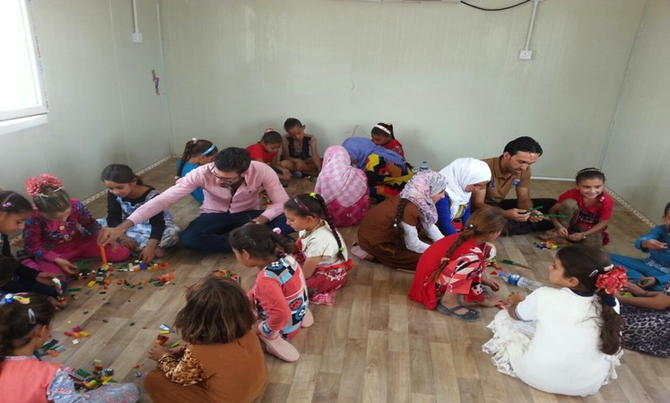

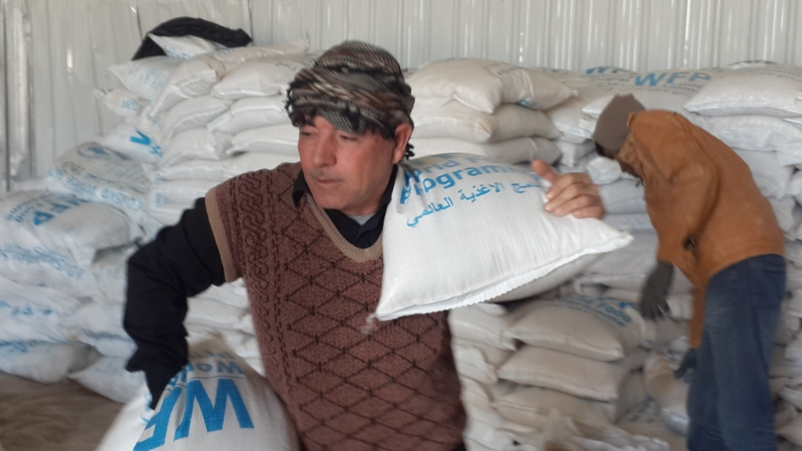

**Mercy Hands for Humanitarian Aid**

[**www.mercyhands.net**](http://www.mercyhands.net)

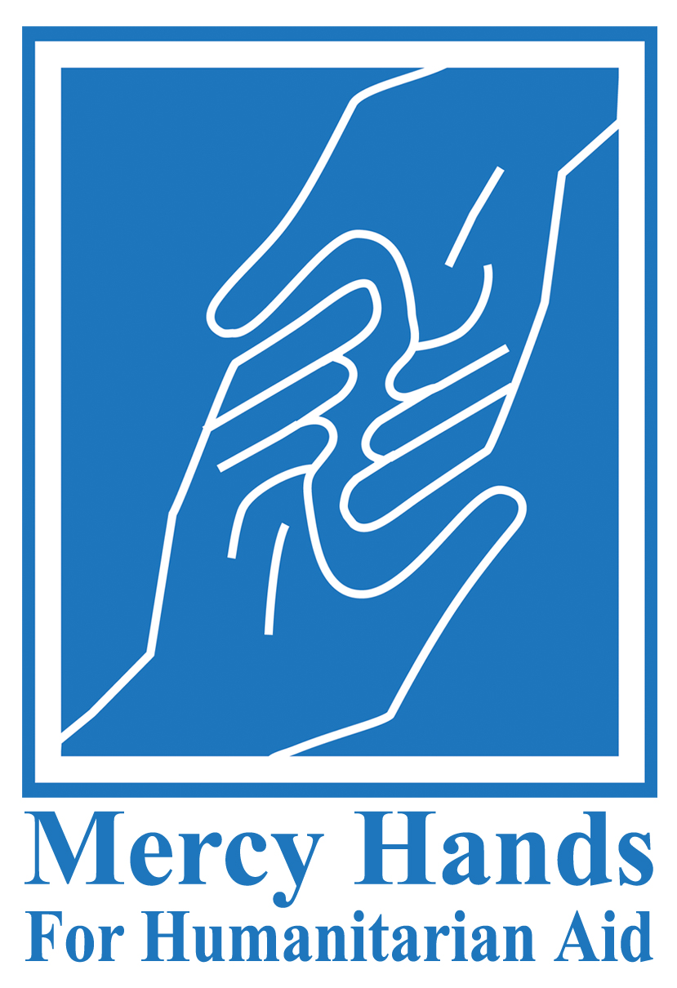

**Mercy Hands for Humanitarian Aid**

[www.mercyhands.net](http://www.mercyhands.net)

Mercy Hands Annual Report | 2016

# Message from the Executive Director

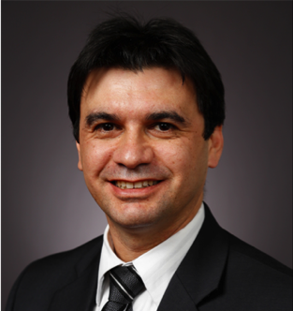Since I was reassigned as Mercy Hands Executive Director in October 2015, and despite of the sleepless night and the impact work has had on my personal life, I feel rewarded every day knowing that we are helping people in need. Many people ask me what motivates me to give it all to help others, and I say: I know how it feels to be helpless and hopeless, as I was an IDP myself during 1991 war on Iraq, when I had to flee out home with my family while the coalition forces’ aircrafts were bombing Baghdad. We left everything behind us and drove all the way to a boarder town. We were hopeless and helpless but then a stranger family opened their doors to us and shared their food and everything with us.

Dr. Khaldoon Al-Moosawi, Executive Director of Mercy Hands

2016 was an extraordinary year for Mercy Hands. The Iraqi government in 2016 launched a massive military offensive against ISIS in central and northern regions of Iraq, which has led to a major humanitarian crisis affecting hundreds of thousands of families. Mercy Hands responded with its full capacity, helping tens of thousands of IDP and vulnerable families. I keep reminding my team that any achievement of Mercy Hands cannot be accredited to one person, because everything we do is the result of teamwork. Indeed, Mercy Hands could have not helped all those people if it was not for the fact that all 208 members excelled in their job.

I am so proud of Mercy Hands achievements and even prouder for working with a great group of dedicated and selfless humanitarian aid workers.

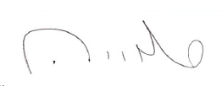  
  
Khaldoon Al-Moosawi  
Executive Director  
Mercy Hands for Humanitarian Aid

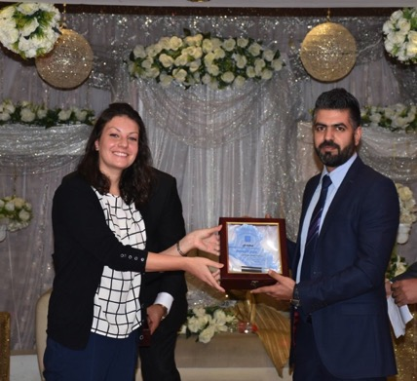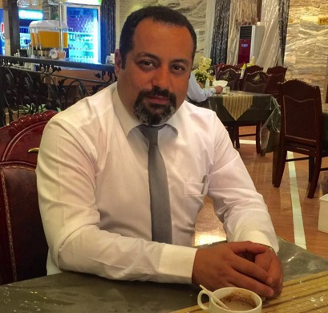**Acknowledgement of Gratitude**

Eng. Mohamad A. Fadhil, Director of Emergency Response Dept. receiving 'Mercy Hands' shield presented by the former General Coordinator.

Mr. Khalid Jawad, Director Assistant of Emergency Response Dept.

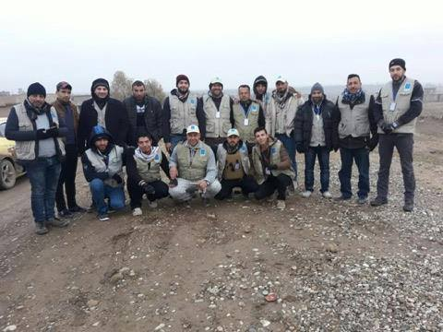All 208 Mercy Hands staff excelled in their work but a special ‘thank you’ is due to the team of Emergency Response Department, headed by Eng. Mohamad A. Fadhil and assisted by Mr. Khalid Jawad, for the extraordinary work they did to help people affected by Mosul military offensive. They were – and still – true heros, working around the clock to deliver aid to people in need. The unfavorable weather conditions and insecurity did not hamper them from getting the job done. They are our heros of 2016!

A group picture of Emergency Response team in Mosul

# Strategic Achievements of 2016

* Rejuvenating Board of Directors: During the period between October 2015 and September 2016, three Board members who served as members for several years were replaced with three competent and enthusiastic members. The new members are: 1) Hayder Kamil; 2) Mohamed Ali Fadhil; and 3) Ahmed Sameer.
* Improving internal control system: To ensure successful and optimal delivery of Mercy Hands programs, the Board of Directors wrote new policies and updated the old ones. Mercy Hands’ policies are available on: <http://www.mercyhands.net/policies/>
* Restructuring the Executive Administration: Before 2016, the Executive Administration consisted of the Executive Director assisted by the General Administrator and General Coordinator. In 2016 a decision was made to add a third assistant and that is the Finance Manager.
* Strengthening Finance Department: before 2016, the General Administrator headed the Finance Department. To promote Mercy Hands’ accountability, the Board of Directors separated between the administrative and financial duties and for the first time assigned a Finance Manager to be the head of the Finance Department.
* Enhancing communication with international stakeholders: In January 2016, Mercy Hands set up a coordination and representation mission in Erbil, Iraq. After a long period of discontinuity, Mercy Hands started to regularly attend UN Clusters meetings and other multiagency coordination meetings held in Erbil, Iraq.
* Enhancing public relations: Mercy Hands Public Relations Department, led by Ms. Duaa Falah, implemented a plan to enhance Mercy Hands’ image as an active and leading humanitarian NGO in Iraq. Among its achievements in 2016, the Public Relations Department created a new website, started a monthly newsletter, and regularly posted about Mercy Hands programs activities on different social media platforms.
* Improving managerial capacity: In 2016 Mercy Hands recruited the first expat General Coordinator based in Baghdad and first expat Representative Coordinator based in Erbil. Moreover, Mercy Hands gained a new Iraqi program manager, Ahmed Hussein, who has a lot of potentials.
* Mercy Hands was registered at the Iraqi Kurdistan Regional Government in Erbil in November 26, 2016.

**Operational Achievements of 2016**

* In 2016, Mercy Hands continued its partnership with WFP and started a new partnership with another UN agency, UNICEF. The partnership with UNICEF is in two different sectors, child protection (psychosocial support) and emergency aid (hygiene kits distribution). Towards the end of 2016, Mercy Hands finalized the arrangements for a partnership with UNHCR for providing legal aid to non-Syrian refugees and stateless people in central and southern Iraq.
* Before 2016, Mercy Hands was working in four governorates: Baghdad, Karbala, Babil, and Basrah. By the end of 2016, Mercy Hands lost its operational presence in Basrah but extended its operational coverage to include a total of seven governorates: Baghdad, Karbala, Babil, Erbil, Salah Al Din, Ninewah, and Anbar. In each of these governorates Mercy Hands has an office, only in Ninewah governorates, which has two offices.
* For the first time, in 2016, Mercy Hands started to work in the field of child psychosocial support.
* In 2016 Mercy Hands became active again in the health sectors. In October 2016 Mercy Hands set up the first charity medical clinic. Moreover, in November, Mercy Hands set up a mobile psychiatric clinic that provides specialized psychiatric care to displaced children in Anbar governorate.
* By December 2016, the total number of Mercy Hands staff was 208, the highest number of paid staff since Mercy Hands was founded in 2004.

# Programs Excerpt

## In 2016, Mercy Hands implemented twenty two programs, projects, and activities. Here is a summary of them:

## EMERGENCY RESPONSE PROJECTS

Mercy Hands entered the year 2016 with six emergency response projects, these are: 1) Management of food storage warehouse in Basrah; 2) Emergency Food Assistance to Populations Affected by Iraq Crisis - Baghdad; 3) Emergency Food Assistance to Populations Affected by Iraq Crisis – Karbala; 4) Management of two food storage warehouses in Baghdad; and 5) Management of Main WFP food storage warehouse in Baghdad (total area of 6000 Sq. meters); and 6) Management of Logistic Cluster warehouse – Baghdad. All these projects continued in 2016, except the “management of food storage warehouse in Basrah”. In addition to the projects continued from 2015, Mercy Hands launched thirteen emergency response projects in 2016; eleven of them are directly related to Mosul humanitarian crisis (see table below).

|  |  |  |  |  |
| --- | --- | --- | --- | --- |
| **Governorate** | **City** | **Project** | **Donor** | **Project Start Date** |
| Baghdad | Baghdad | Management of food storage warehouse | WFP | Sep-2016 |
| Management of food storage warehouse | WFP | Dec-2016 |
| Ninewah | Mosul | Emergency Food Assistance to Populations Affected by Iraq Crisis | WFP | Dec-2016 |
| Hygiene kits distribution to the liberated quarters in Mosul Center. | UNICEF | Dec-2016 |
| Qayyarah | Management of Logistic Cluster warehouse – Jadaah Camp for IDPs | WFP | Dec-2016 |
| Emergency Food Assistance to Populations Affected by Iraq Crisis in Qayarah, Shora, Hammam Al-Aleel, Hadher , Jeddah Camp, Airstrip Camp and Hal Ali Camp | WFP | Oct-2016 |
| Affected by Iraq Crisis in Qayarah, Shora, Hammam Al-Aleel, Hadher , Jeddah Camp, Airstrip Camp and Hal Ali Camp | WFP | Dec-2016 |
| Management of Logistic Cluster 2 warehouses – Haj Ali Camp for IDPs | WFP | Dec-2016 |
| Management of 2 food storage warehouses | WFP | Dec-2016 |
| Hygiene Kit Distribution for IDPs Fleeing Mosul | HELP | Nov-2016 |
| Distribution of Baby Kits to Conflict-affected IDPs in Qayyarah Airstrip, Ninewah Governorate | Save the Children | Dec-2016 |
| Salah Al Din | Tikrit | Management of Logistic Cluster warehouse. | WFP | Oct-2016 |
| Prepositioning of emergency ready-to-eat food rations in Central Iraq | OCHA-IHPF | Oct-2016 |

Through the aid distribution projects, Mercy Hands delivered food and/or NFI to a total of **105961** IDP and vulnerable families. The following graph shows a breakdown of the number of families per project in 2016.

## CHILD PROTECTION

### 1- Psychosocial Support for IDP Children in Anbar

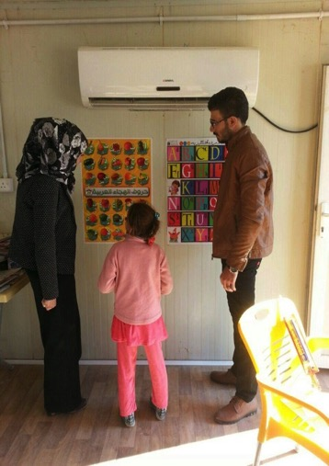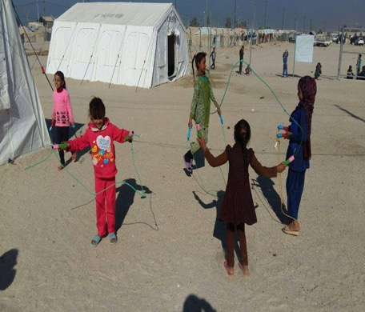In October 2016, Mercy Hands started its first partnership with UNICEF and it was about providing psychosocial support to IDP children in Anbar governorate. The official title of the program is “Responding to the child protection needs of girls and boys in Khaldiya and Habaniya affected by the IDPs crisis in the ongoing conflict from Anbar”. The goals of the program are: to provide psychosocial support through indoor and outdoors play activities and culturally appropriate games to the most vulnerable IDP children, identify children who require specialized psychological care and provide it to them, and to raise awareness of children, parents, and the local community on relevant issues such as child rights and prevention of family separation. To achieve these goals, Mercy Hands established two child friendly spaces (CFSs) at the two IDP camps in Khaldiya and Habaniya cities and supplied them with many different child recreational and educational toys. Psychosocial workers run the two CFSs and a Program Manager based at Mercy Hands Headquarters in Baghdad manages the whole program.

Children playing outside one of the two Child Friendly Spaces in Anbar

Figure The CSF psychosocial workers worked closely with the children to promote their psychosocial well being.

### 2- Begging and Child Labor in Karbala Workshop

### On the 20th of August 2016 Mercy Hands conducted a 3-hour workshop to address the ongoing problem in Karbala of child begging and labor. Mercy Hands’ facilitator in Karbala, Mr. Nawras Adnan, headed the workshop and the invitees of the workshop amounted to 20 participants who were comprised of representatives from local and international civil society organizations, the Karbala police department, and the Iraqi Parliament representative for Karbala.

The workshop was organized into three sessions: 1) Statistics and facts; 2) The effect of this phenomenon on the society; and 3) Solutions.

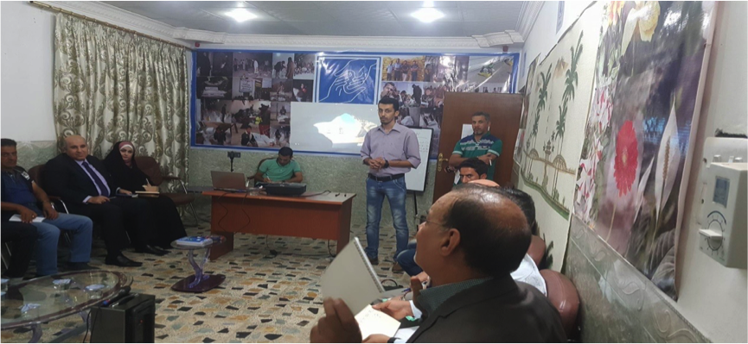

Mr. Nawaras Adnan (middle) led the workshop

# IRAQI ALUMNI ASSOCIATION DEVELOPMENT

# In February 2016, and through Mercy Corps, the U.S. Embassy in Baghdad contracted with Mercy Hands to train the Iraqi alumni of U.S. exchange programs and organize them into two Alumni Associations: Central and Northern Regions of Iraq (the Alumni Association for Southern Region was already established). Mercy Hands’ Civil Society Department, which consists of highly experienced civil society trainers, guided the alumni to elect their General Assembly and Board of Directors and then engaged the members of General Assembly and Board of Directors into a series of workshops. The first workshop was for Organizational Capacity Assessment and the purpose was to make all participants more aware about the seven key capacity areas of organizational development, addressing their strong & weak points, challenges and opportunities, in addition to the establishment of their development plan. Then participants were engaged in organizational development training courses. The following are examples of the conducted organizational development training courses:

1. Governance and leadership.
2. Strategic management.
3. Project design and management.
4. External relations and community mobilization.
5. Human resources and volunteer recruitment.
6. Financial management and sustainability
7. Information management.

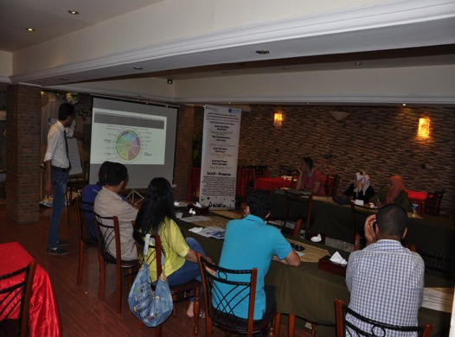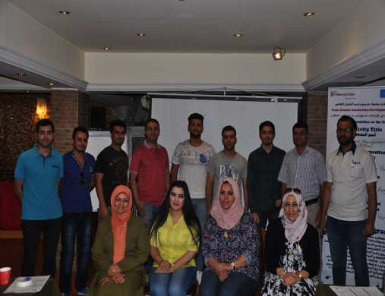

The Alumni were engaged in many organizational development training courses.

A group picture of members of the Iraqi Alumni Association - Central Region

In the final phase of the program Mercy Hands facilitated the official registration of the two associations and then supervised them to implement small-scale community projects, such as: Giving Bus – Baghdad.

1. Together for a clean and civilized city.
2. Education and counseling program for young leaders IYLEP.
3. For our children develop our schools.
4. Empowering young women to become future leaders.
5. Religious and Ethnic Pluralism Workshop.

The two Associations are currently active and they are available on Facebook: [**https://www.facebook.com/DHAAlu/**](https://www.facebook.com/DHAAlu/)and <https://www.facebook.com/epaorganization/?fref=ts>

The project was concluded in November 2016.

## IDP LEGAL AID CLINIC

In October 2016 Mercy Hands received a grant from Tetra Tech DPK (implementer of the United States Department of State’s Human Rights and Rule of Law Iraq project) to provide legal services to IDPs in Babil governorate. The project duration is eleven month, starting in October 2016 and ending in August 2017. The core team is made of highly experienced lawyers who are based in Babil city. These lawyers provide legal and administrative representation and consultation to IDPs in Babil governorate. In addition, the lawyers work on raising IDPs awareness about their rights and legal services available to them, by conducting workshops, distributing brochures, and 2 workshops and production and airing of radio spots.

As of January 2017, the lawyers have provided legal aid to a total of 193 IDPs, 115 legal consultations and 78 legal representations.

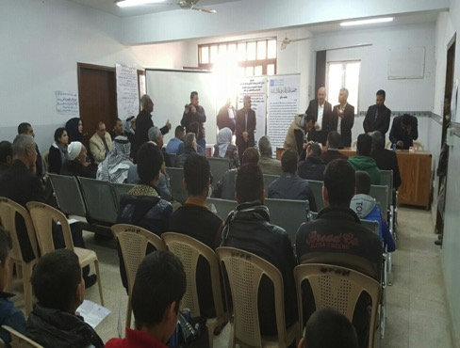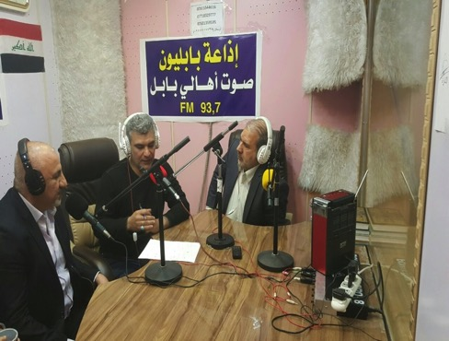

One of the IDP raising awareness workshops conducted by Mercy Hands' lawyers

Mercy Hands produced and aired radio spots to reach out to IDPs

## HEALTH PROGRAMS

In 2016, Mercy Hands implemented the following health projects:

### 1- Rahma (Mercy) Charity Clinic in Baghdad

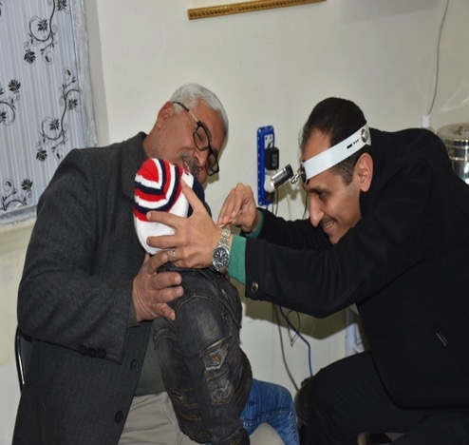In mid October 2016, the Iraqi Telemedicine Center launched Rahma (Mercy) Charity Clinic. The clinic is located at the same building that host the Iraqi Telemedicine Center, at the heart of Baghdad.

The clinic is funded by a private donation from Dr. Khaldoon Al-Moosawi, Founder and Chairman of Board of Director of Mercy Hands for Humanitarian Aid and the Iraqi Telemedicine Center. The staff of the clinic consists of the Medical Director (Dr. Muthanna Al-Kaabi), Administrative Director (Mr. Hussein Al-Mukhtar), a Nurse, and a Lab Director.

The clinic provides the following services: physician care, ECG, Ultrasound, minor surgeries, urgent procedures (IV fluid administration and nebulizer), and a wide variety of lab tests. The clinic is open to everyone, but a priority is given to underprivileged poor people. All services are provided free of charge for internally displaced persons, orphans, victims of war, unemployed, low income families, members of Iraqi military forces and their families, and anyone who cannot afford to pay. However, those who can pay are charged subsidized fees for the services provided. The collected fees will be used to cover the running cost of the clinic and to sustain its operations.

Dr. Muthanna Al-Kaabi, Medical Director of Rahma clinic, is examining one of the children.

### 2- Symposium on "Telemedicine: An Opportunity for Advancement of Healthcare in Iraq"

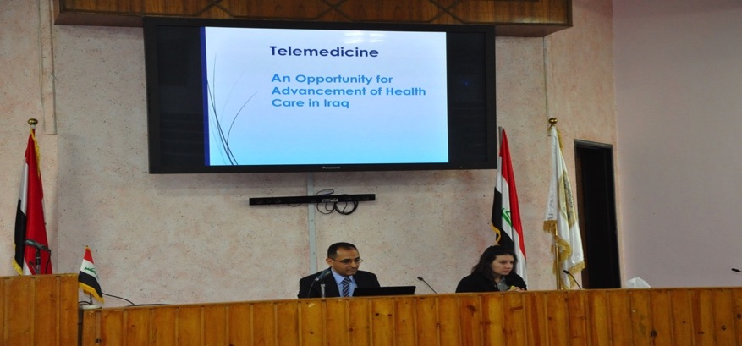In October and November 2016, the Iraqi Telemedicine Center conducted a series of symposiums titled “Telemedicine: An Opportunity for Advancement of Healthcare in Iraq”. The purpose of the symposiums was to raise awareness on telemedicine and the targeted audience was healthcare professionals. The symposiums took place at different medical schools in Baghdad. This symposium addressed how to improve access to healthcare in Iraq by utilizing the internet and other telecommunication technologies. The audience was very interested in the topic and they had many questions to ask about telemedicine in general and the work of the Iraqi Telemedicine Center.

Dr. Muthanna Al-Kaabi giving a presentation at the telemedicine symposium held in Al-Nahrain College of Medicine in Baghdad, sitting next to him is the former General Coordinator of Mercy Hands, Christa Waegemann.

### 3- Mobile Psychiatric Clinic for IDP Children in Anbar Governorate

While working on IDPs in Anbar, Mercy Hands’ psychosocial workers observed many children showing signs and symptoms of psychiatric disorders such as PTSD and depression. Therefore, Mercy Hands set up a mobile psychiatric clinic that provides specialized psychiatric care to displaced children at the two IDPs camps in Anbar governorate.

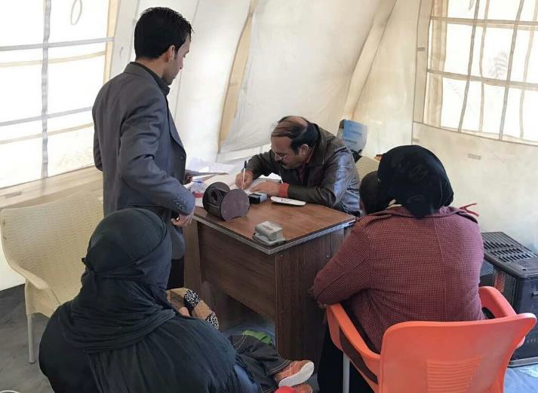The clinic was managed by Dr. Fadhil (showing in the picture above) who is board certified in psychiatry.

A total of 99 children were assessed for psychiatric disorders

### 4- Health Related Research

Another activity conducted by the Iraqi Telemedicine Center in 2016 was a survey study titled “Reality Check of Internet and Telemedicine Use in Iraqi Hospitals”. This study was accepted for poster presentation at Med-e-Tel 2017, taking place on April 5-7, 2017, in Luxembourg, and it will be published in the Journal of the International Society for Telemedicine & eHealth (JISfTeH).

### 

Brochure of Dhamani Health Insurance Program

### 5- Health Insurance Program for Low Income Families

Health insurance is rudimentary in Iraq and almost all patients pay out of pocket for healthcare. The need for health insurance is more now than ever, especially since the Iraqi government decided to increase the fees of most public healthcare services. Mercy Hands responded to this need by launching a health insurance program in December 2016, named “Dhamani”, designed specifically for low-income families. Simply stated, for a small premium, the insured individual or family will have access to all services provided by Rahma Clinic either free of charge or for a very small co-pay.

## EDUCATION

In August 2016, Mercy Hands conducted a workshop in Tikrit to address the educational challenges facing host and IDP children in Salah Al Din. Here is an infographic of the workshop:

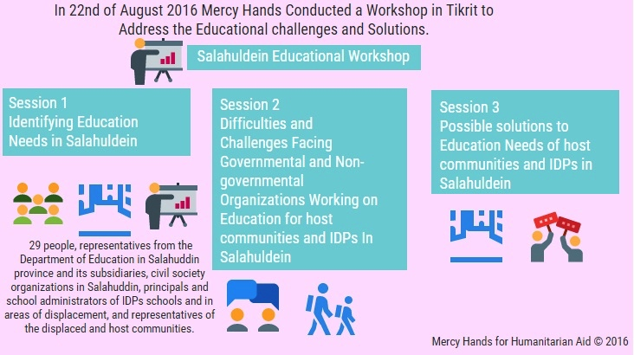

# Surveys and Research

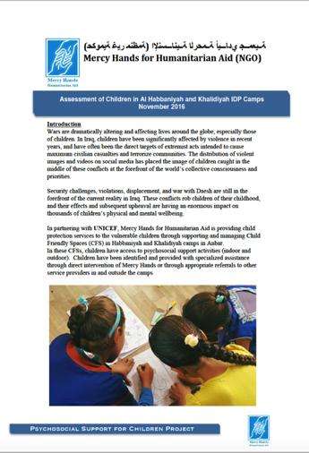In addition to designing and implementing humanitarian projects, Mercy Hands also conducts population surveys and studies in different areas. In 2016, Mercy Hands conducted the following surveys and studies:

1. Survey: Who is thinking about emigrating from Iraq and what would change their mind?
2. IDPs in Iraq – Destinations Unknown: Ain Al Tamur City
3. [The Evolution of Internet in Iraq](http://tele-doctors.com/the-evolution-of-internet-in-iraq/)
4. The Effects of Conflict on Mental Health and Social Behavior of Children
5. Survey Study: Reality Check of Internet & Telemedicine Use in Iraqi Hospitals

These studies are available on Mercy Hands’ websites and they were published on NCCI (NGOs Coordination Committee for Iraq) website as well as other public media outlets. Noteworthy, the study “Survey Study: Reality Check of Internet & Telemedicine Use in Iraqi Hospitals” was accepted as a poster in Med-e-Tel 2017 expo which will be held in Luxembourg in April 2017, and the abstract of the study will be published in the Journal of the International Society for Telemedicine and eHealth.

# Public Relations

Mercy Hands Public Relations Department has successfully been able to engage the public and build a strong relationship with them.

Mercy Hands owns three websites:

1. The organization’s main website: [www.mercyhands.net](http://www.mercyhands.net)
2. Iraqi Telemedicine Center: [www.tele-doctors.com](http://www.tele-doctors.com)
3. Broadening Participation through Civil Society (BPCS) program: [www.musharakah.net](http://www.musharakah.net)

The Iraqi Telemedicine Center is one of Mercy Hands self-funded medical initiatives, which is still ongoing, while BPCS is a civil society program that was implemented by Mercy Hands (2013 – 2015).

Mercy Hands is also on the following social media platforms:

1. Facebook: [www.facebook.com/MercyHands](http://www.facebook.com/MercyHands) and [www.facebook.com/mercyhandsarabic](http://www.facebook.com/mercyhandsarabic)
2. Instagram: [www.instagram.com/mercy_hands](http://www.instagram.com/mercy_hands)
3. Twitter: [www.twitter.com/MercyHands](http://www.twitter.com/MercyHands)
4. Youtube: [www.youtube.com/channel/UCA2_en3zb_d8nTsXo6BwTHg](http://www.youtube.com/channel/UCA2_en3zb_d8nTsXo6BwTHg)
5. LinkedIn: [www.linkedin.com/company/mercy-hands-for-humanitarian-aid](http://www.linkedin.com/company/mercy-hands-for-humanitarian-aid)
6. Google: <https://plus.google.com/112843464227330484234>
7. Flickr: [www.flickr.com/mercyhands](http://www.flickr.com/photos/mercyhands)

The English Facebook page has 10,882 likes while the Arabic page has 4,408 likes. Mercy Hands has 386 followers on Instagram and there were 87 photos and video clips posted on Instagram in 2016. The three most liked Instagram photos are the following:

**1**

# Preparations are ongoing to open Rahma (Mercy) Charity Clinic in Baghdad, Iraq. Starting date: October 2, 2016. (41 likes)

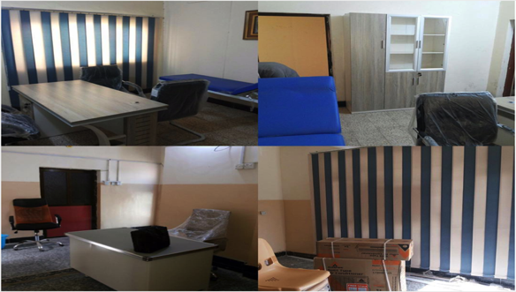

**2**

**3**

# Last week we launched a new project for providing psychosocial support to IDP children in Anbar governorate. We established 2 Child Friendly Spaces in 2 IDP camps in Anbar and over a period of 3 months our psychosocial workers will identify 1200 most vulnerable children and engage them in educational, recreational, and social activities to support their well-being. Children with serious or complicated psychological issues will be referred for specialized care. This project is funded by UNICEF. (35 likes)

# Our brave Coordinator, Miriam Medina, is among our brave team of distribution officers at Jad'ah IDP Camp, which is only 73 kilometer (45 miles) south of Mosul. Despite of security concerns, Miriam insisted on going on field. She is a genuine humanitarian aid worker and the world definitely needs more people like her. (39 likes)

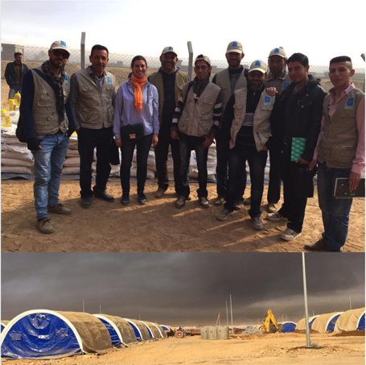

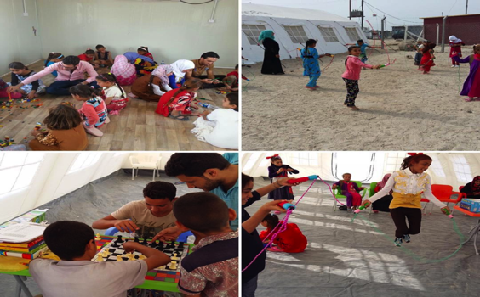

# Looking Forward

In 2017 Mercy Hands will focus on the following issues:

* Better defining the roles of Board members and enhance the Board’s functionality.
* Continue improving the internal control system and writing organizational procedures and policies.
* Continue and promote the partnerships with current donors.
* Expand and diversify the portfolio of donors
* Search for sources of funding other than international donors, mainly focusing on exploring opportunities for income generating projects.
* Be active in more humanitarian sectors.
* Expand operational coverage to include more governorates and areas.
* Set up humanitarian missions outside Iraq.